

**CAPSTONE PROJECT REPORT**

**Report 4 – Software Design Document**

**Table of Contents**

I. Project Report 3

1. Status Report 3

2. Team Involvements 3

3. Issues/Suggestions 3

II. Software Design Document 4

1. Overall Description 4

1.1 Assumptions 4

1.2 Design Constraints 4

1.3 [Technology Suggestion] 5

2. System Architecture Design 5

2.1 Overall Architecture 5

2.2 System Architecture 5

2.3 Package Diagram 5

3. System Detailed Design 6

3.1 <Feature Name1> 6

4. Data & Database Design 8

4.1 Database Design 8

4.2 Data File Design 9

# I. Project Report

## 1. Status Report

|  |  |  |  |
| --- | --- | --- | --- |
| **#** | **Work Item** | **Status** | **Notes (Work Item in Details)** |
| 1 |  | Pending |  |
| 2 |  | In Progress |  |
| 3 |  | Completed |  |

## 2. Team Involvements

|  |  |  |  |
| --- | --- | --- | --- |
| **#** | **Task** | **Member** | **Notes (Task Details, etc.)** |
| 1 |  | KienNT |  |
| 2 |  | TuanTV |  |
| 3 |  | AnhLM |  |

## 3. Issues/Suggestions

|  |  |  |  |
| --- | --- | --- | --- |
| **#** | **Issue** | **Status** | **Notes (Solution, Suggestion, etc.)** |
| 1 |  | Pending |  |
| 2 |  | In Progress |  |
| 3 |  | Completed |  |

# II. Software Design Document

## 1. Overall Description

### 1.1 Assumptions

This system is designed basing on these following assumptions:

* Android
* IOS
* Microsoft SQL Server
* Microsoft Azure

### 1.2 Design Constraints

This system should be compiled with following items:

* Use JWT authentication.
* Use Android SDK 21 to 29.
* IOS greater than 9.0.
* Every process in the system takes less than 10 seconds.

## 2. System Architecture Design

### 2.1 Overall Architecture

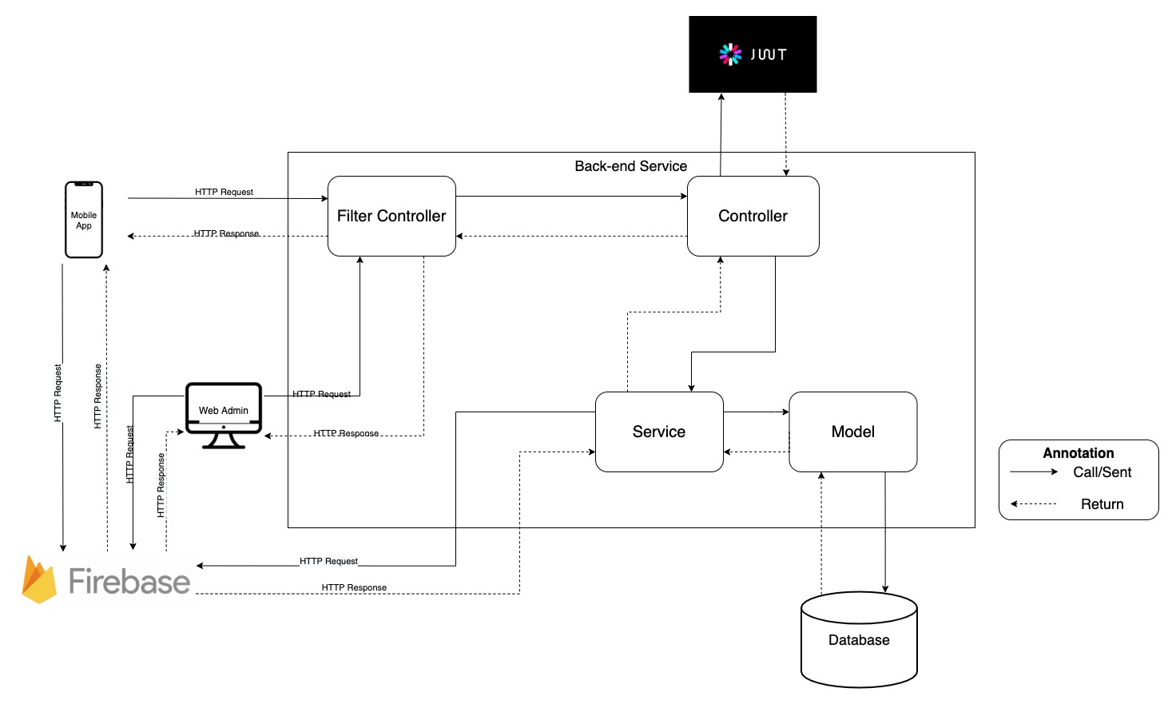*figure 1: Architecture Diagram*

The Master Vietnamese system consists of 3 components: Spring-boot server provides REST APIs, mobile application for learners, and web application for admin.

We also use third-party services such as Firebase for login and push notification function, and Azure for deploying REST APIs.

### 2.2 System Architecture

### 2.2.1 Web Server Architecture

* We use three tiers architecture to build our web server. We decide to use this architecture because:
  + It gives us the ability to develop and enhance a product with greater speed than developing on a single code base.
  + It provides an ease of maintenance of the code base, managing presentation code and business logic separately.

### 2.2.2 Mobile Application Architecture

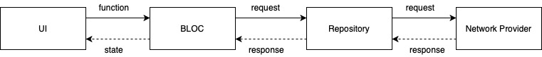

### *figure 2: BLOC pattern*

* We use BLOC pattern to separate our mobile application into three layers:
  + - UI
    - BLOC: BLOC receives a stream of data from repository, handles any required business logic and publishes streams of data changes to screens that are interested in them.
    - Data: Repository and Network Provider ( Retrieve data from REST APIs)

### 2.3 Package Diagram

### 2.3.1 Mobile Application

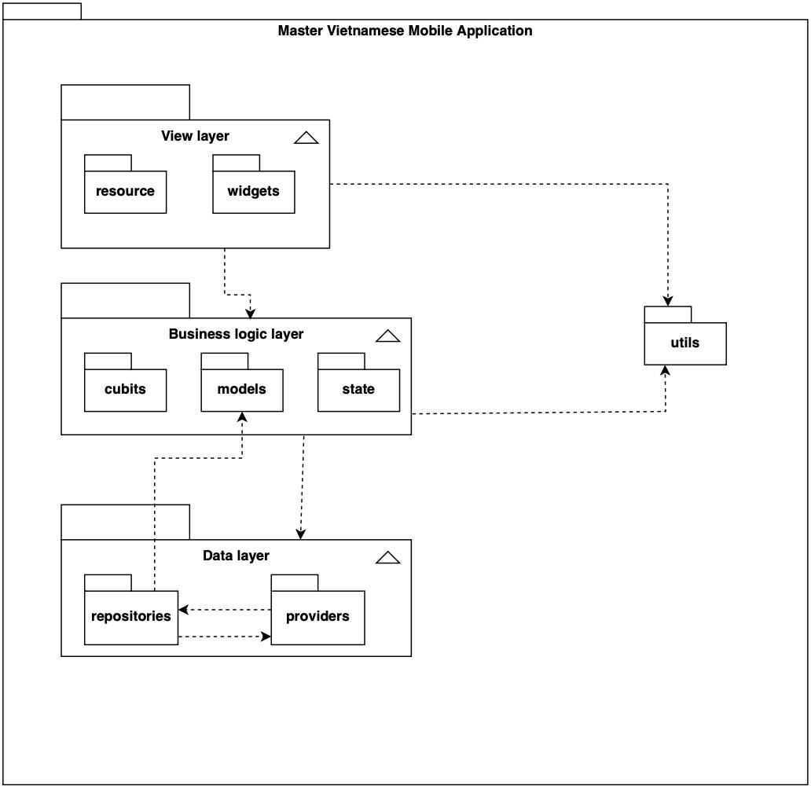

### *figure 3: Mobile application package diagram*

|  |  |  |
| --- | --- | --- |
| **No** | **Package** | **Description** |
| 01 | screens | This package contains classes for UI implementation |
| 02 | widgets | This package contains classes for Widget implementation for UI |
| 03 | cubits | This package contains classes for implement bloc pattern |
| 04 | states | This package contains classes to implement state of screens |
| 05 | models | This package contains classes to map object to json from API |
| 06 | repository | This package contains classes for handle data between REST APIs and Mobile application |
| 07 | providers | This package contains classes for communicating to REST APIs server |
| 08 | utils | This package contains supported classes |

### 2.3.2 Back-end package diagram

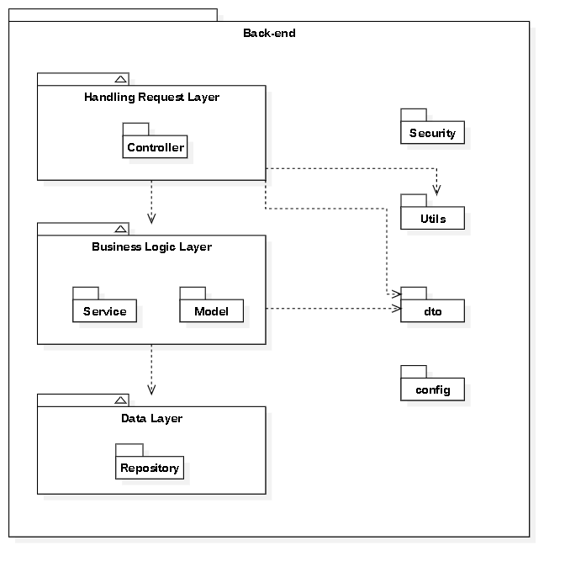

### *figure 4: Back-end package diagram*

|  |  |  |
| --- | --- | --- |
| **No** | **Package** | **Description** |
| 01 | Controller | This package contains classes for receiving request processing and respond to the results |
| 02 | Service | This package contains classes for business logic processing |
| 03 | Model | This package contains classes(Entity) to representing tables in the database |
| 04 | Repository | This package contains classes to execute the query to the database |
| 05 | Security | This package contains classes to implement authorization, authentication and jwt |
| 06 | Utils | This package contains the class to handle email delivery |
| 07 | dto | This package contains classes that contain the data returned to client |
| 08 | config | This package contains the class to handle swagger |

## 3. System Detailed Design

### 3.1 Overall

#### a. Class Diagram

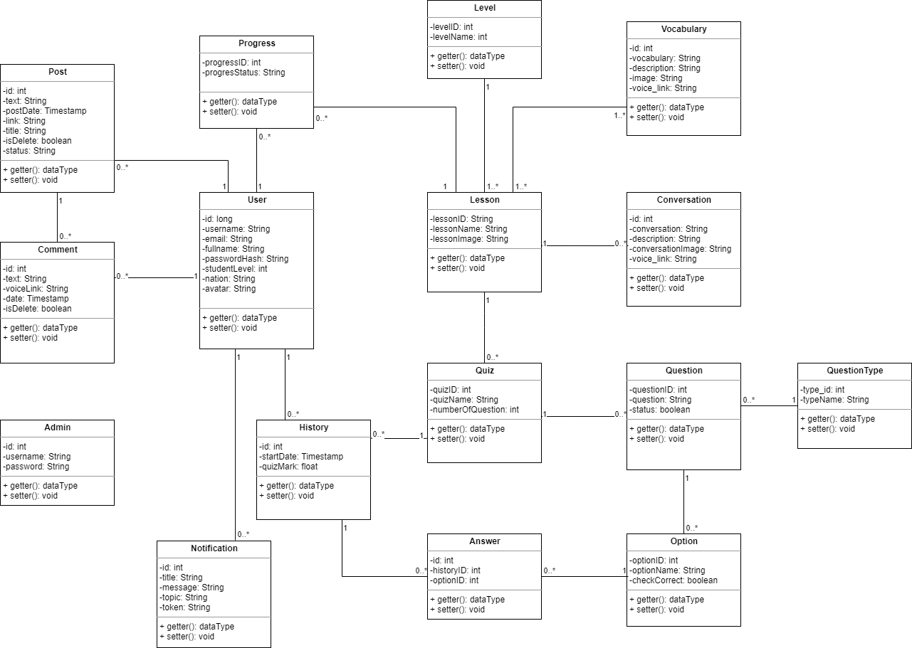

### *figure 5: Class diagram*

#### b. Class Specification

##### b1. User

|  |  |  |  |
| --- | --- | --- | --- |
| **Attribute** | **Type** | **Visibility** | **Description** |
| id | Long | private | Unique identifier of a user |
| username | String | private | The attribute represents username of a user |
| passwordHash | String | private | The attribute represents password of a user |
| fullname | String | private | The attribute represents full name of a user |
| avatar | String | private | The attribute represents avatar link of a user |
| email | String | private | The attribute represents email of a user |
| studentLevel | int | private | The attribute represents level of a user |
| roleID | int | private | The attribute represents role of a user |
| nation | String | private | The attribute represents nation of a user |

|  |  |  |  |  |
| --- | --- | --- | --- | --- |
| **No** | **Method** | **Visibility** | **Return Type** | **Description** |
| 1 | getter | public | Attribute Type | get attribute value |
| 2 | setter | public | void | set attribute value |

##### b2. Progress

|  |  |  |  |
| --- | --- | --- | --- |
| **Attribute** | **Type** | **Visibility** | **Description** |
| progressID | int | private | Unique identifier of a progress |
| progresStatus | String | private | The attribute represents status of progress |

|  |  |  |  |  |
| --- | --- | --- | --- | --- |
| **No** | **Method** | **Visibility** | **Return Type** | **Description** |
| 1 | getter | public | Attribute Type | get attribute value |
| 2 | setter | public | void | set attribute value |

##### b3. Level

|  |  |  |  |
| --- | --- | --- | --- |
| **Attribute** | **Type** | **Visibility** | **Description** |
| levelID | int | private | Unique identifier of a level |
| levelName | String | private | The attribute represents name of a level |
| status | boolean | private | The attribute represents status of a level |

|  |  |  |  |  |
| --- | --- | --- | --- | --- |
| **No** | **Method** | **Visibility** | **Return Type** | **Description** |
| 1 | getter | public | Attribute Type | get attribute value |
| 2 | setter | public | void | set attribute value |

##### b5. Lesson

|  |  |  |  |
| --- | --- | --- | --- |
| **Attribute** | **Type** | **Visibility** | **Description** |
| lessonID | int | private | Unique identifier of a lesson |
| lessonName | String | private | The attribute represents name of a lesson |
| lessonImage | String | private | The attribute represents image of a lesson |
| status | String | private | The attribute represents status of a lesson |

|  |  |  |  |  |
| --- | --- | --- | --- | --- |
| **No** | **Method** | **Visibility** | **Return Type** | **Description** |
| 1 | getter | public | Attribute Type | get attribute value |
| 2 | setter | public | void | set attribute value |

##### b6. Conversation

|  |  |  |  |
| --- | --- | --- | --- |
| **Attribute** | **Type** | **Visibility** | **Description** |
| id | int | private | Unique identifier of a conversation |
| conversation | String | private | The attribute represents a conversation |
| description | String | private | The attribute represents description of a conversation |
| conversationImage | String | private | The attribute represents image link of a conversation |
| voice_link | String | private | The attribute represents voice link of a conversation |
| status | boolean | private | The attribute represents status of a conversation |

|  |  |  |  |  |
| --- | --- | --- | --- | --- |
| **No** | **Method** | **Visibility** | **Return Type** | **Description** |
| 1 | getter | public | Attribute Type | get attribute value |
| 2 | setter | public | void | set attribute value |

##### b7. Vocabulary

|  |  |  |  |
| --- | --- | --- | --- |
| **Attribute** | **Type** | **Visibility** | **Description** |
| id | int | private | Unique identifier of a vocabulary |
| vocabulary | String | private | The attribute represents a vocabulary |
| description | String | private | The attribute represents description of a vocabulary |
| image | String | private | The attribute represents image link of a vocabulary |
| voice_link | String | private | The attribute represents voice link of a vocabulary |
| status | boolean | private | The attribute represents status of a vocabulary |

|  |  |  |  |  |
| --- | --- | --- | --- | --- |
| **No** | **Method** | **Visibility** | **Return Type** | **Description** |
| 1 | getter | public | Attribute Type | get attribute value |
| 2 | setter | public | void | set attribute value |

##### b8. Quiz

|  |  |  |  |
| --- | --- | --- | --- |
| **Attribute** | **Type** | **Visibility** | **Description** |
| quizID | int | private | Unique identifier of a quiz |
| quizName | String | private | The attribute represents name of a quiz |
| numberOfQuestion | int | private | The attribute represents number of question in quiz |

|  |  |  |  |  |
| --- | --- | --- | --- | --- |
| **No** | **Method** | **Visibility** | **Return Type** | **Description** |
| 1 | getter | public | Attribute Type | get attribute value |
| 2 | setter | public | void | set attribute value |

##### b9. Question

|  |  |  |  |
| --- | --- | --- | --- |
| **Attribute** | **Type** | **Visibility** | **Description** |
| questionID | int | private | Unique identifier of a question |
| question | String | private | The attribute represents a question |
| status | boolean | private | The attribute represents status of a question |

|  |  |  |  |  |
| --- | --- | --- | --- | --- |
| **No** | **Method** | **Visibility** | **Return Type** | **Description** |
| 1 | getter | public | Attribute Type | get attribute value |
| 2 | setter | public | void | set attribute value |

##### b10. Option

|  |  |  |  |
| --- | --- | --- | --- |
| **Attribute** | **Type** | **Visibility** | **Description** |
| optionID | int | private | Unique identifier of a option |
| optionName | String | private | The attribute represents a option |
| checkCorrect | String | private | The attribute represents if option is correct or not |
| status | boolean | private | The attribute represents status of a option |

|  |  |  |  |  |
| --- | --- | --- | --- | --- |
| **No** | **Method** | **Visibility** | **Return Type** | **Description** |
| 1 | getter | public | Attribute Type | get attribute value |
| 2 | setter | public | void | set attribute value |

##### b11. History

|  |  |  |  |
| --- | --- | --- | --- |
| **Attribute** | **Type** | **Visibility** | **Description** |
| id | int | private | Unique identifier of history |
| startDate | Timestamp | private | The attribute represents date and time when user take quiz |
| quizMark | float | private | The attribute represents user quiz’s mark |

|  |  |  |  |  |
| --- | --- | --- | --- | --- |
| **No** | **Method** | **Visibility** | **Return Type** | **Description** |
| 1 | getter | public | Attribute Type | get attribute value |
| 2 | setter | public | void | set attribute value |

##### b12. Post

|  |  |  |  |
| --- | --- | --- | --- |
| **Attribute** | **Type** | **Visibility** | **Description** |
| id | Long | private | Unique identifier of a post |
| text | String | private | The attribute represents content of a post |
| postDate | Timestamp | private | The attribute represents date and time a post has been posted |
| link | String | private | The attribute represents voice or video link in a post |
| title | String | private | The attribute represents title of a post |
| isDelete | boolean | private | The attribute represents if a post has been delete or not |
| status | int | private | The attribute represents status of a post |

|  |  |  |  |  |
| --- | --- | --- | --- | --- |
| **No** | **Method** | **Visibility** | **Return Type** | **Description** |
| 1 | getter | public | Attribute Type | get attribute value |
| 2 | setter | public | void | set attribute value |

##### b13. Comment

|  |  |  |  |
| --- | --- | --- | --- |
| **Attribute** | **Type** | **Visibility** | **Description** |
| id | int | private | Unique identifier of a comment |
| text | String | private | The attribute represents content of a comment |
| voiceLink | String | private | The attribute represents voice link of a post |
| date | Timestamp | private | The attribute represents date and time user comment |
| isDelete | boolean | private | The attribute represents if a comment has been delete or not |

|  |  |  |  |  |
| --- | --- | --- | --- | --- |
| **No** | **Method** | **Visibility** | **Return Type** | **Description** |
| 1 | getter | public | Attribute Type | get attribute value |
| 2 | setter | public | void | set attribute value |

##### b14. Admin

|  |  |  |  |
| --- | --- | --- | --- |
| **Attribute** | **Type** | **Visibility** | **Description** |
| id | int | private | Unique identifier of a admin |
| username | String | private | The attribute represents admin’s username |
| password | String | private | The attribute represents admin’s password |

|  |  |  |  |  |
| --- | --- | --- | --- | --- |
| **No** | **Method** | **Visibility** | **Return Type** | **Description** |
| 1 | getter | public | Attribute Type | get attribute value |
| 2 | setter | public | void | set attribute value |

##### b15. Notification

|  |  |  |  |
| --- | --- | --- | --- |
| **Attribute** | **Type** | **Visibility** | **Description** |
| id | int | private | Unique identifier of a notification |
| title | String | private | The attribute represents title of notification |
| message | String | private | The attribute represents message of a notification |
| topic | String | private | The attribute represents topic of a notification |
| token | String | private | The attribute represents user token |

|  |  |  |  |  |
| --- | --- | --- | --- | --- |
| **No** | **Method** | **Visibility** | **Return Type** | **Description** |
| 1 | getter | public | Attribute Type | get attribute value |
| 2 | setter | public | void | set attribute value |

##### b16. Answer

|  |  |  |  |
| --- | --- | --- | --- |
| **Attribute** | **Type** | **Visibility** | **Description** |
| id | int | private | Unique identifier of user’s answer |
| historyID | int | private | The attribute represents history of a quiz that user had take |
| optionID | int | private | The attribute represents option that user had answered |

|  |  |  |  |  |
| --- | --- | --- | --- | --- |
| **No** | **Method** | **Visibility** | **Return Type** | **Description** |
| 1 | getter | public | Attribute Type | get attribute value |
| 2 | setter | public | void | set attribute value |

#### c. Sequence Diagram(s)

#### Login Diagram

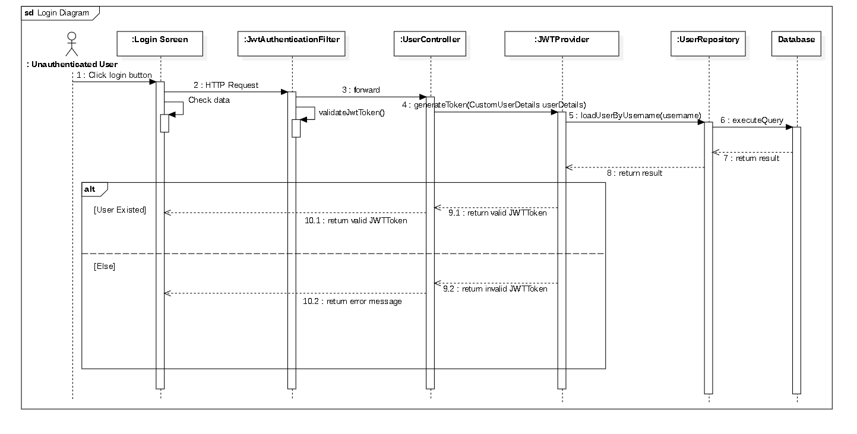

### *figure 6: Login sequence diagram*

#### Approval Post Diagram

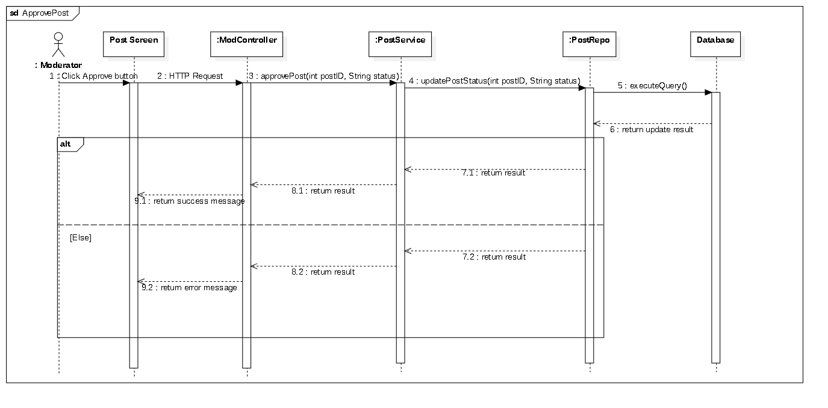

### *figure 7: Approve post sequence diagram*

#### Create Lesson Diagram

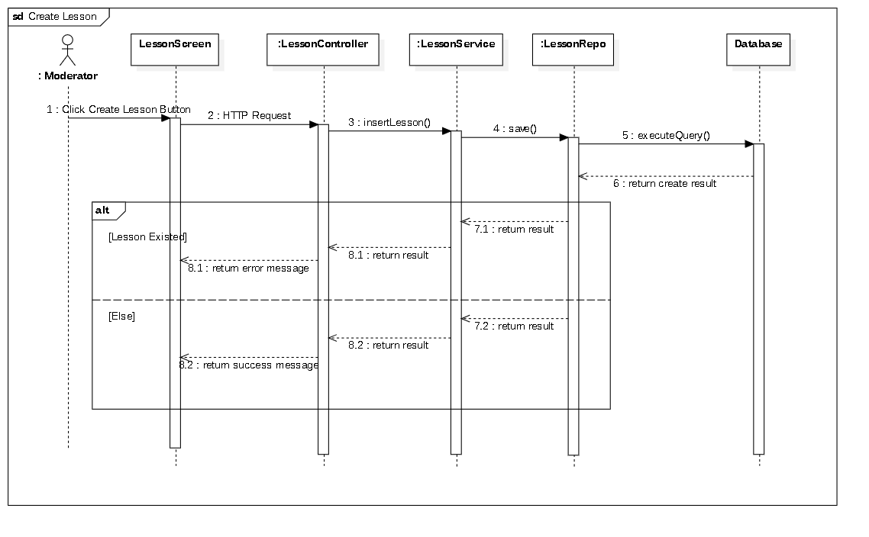

### *figure 8:Create lesson sequence diagram*

#### Add Vocabulary Diagram

### *figure 9: Add vocabulary sequence diagram*

#### d. Activity Diagram(s)

#### 1. <Learner> Show lesson activity

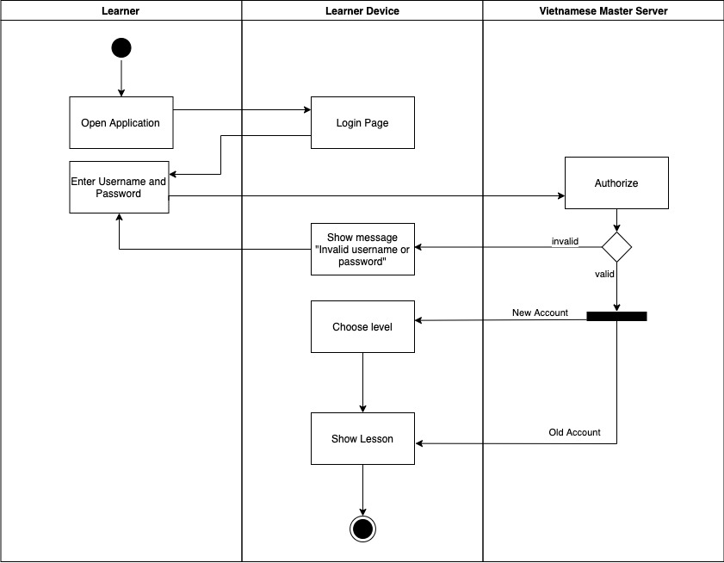*figure 10: Show lesson activity diagram*

#### 2. <Learner> Sign Up Activity

### *figure 11: Sign Up activity diagram*

#### 3. <Learner> Vocabulary Activity

### *figure 12: Vocabulary activity diagram*

#### 4. <Learner> Conversation Activity

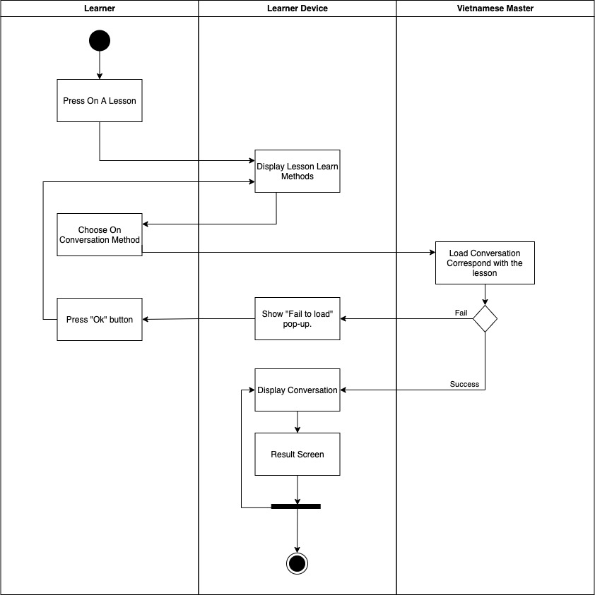*figure 13: Conversation activity diagram*

#### 5. <Learner> Quiz Activity

### *figure 14: Quiz activity diagram*

#### 6. <Learner> Create Post Activity

### *figure 15: Create Post activity diagram*

#### 7. <Learner> Delete Post Activity

### *figure 16: Delete Post activity diagram*

#### 8. <Learner> View Post Activity

### *figure 17: View Post activity diagram*

## 4. Data & Database Design

### 4.1 Database Design

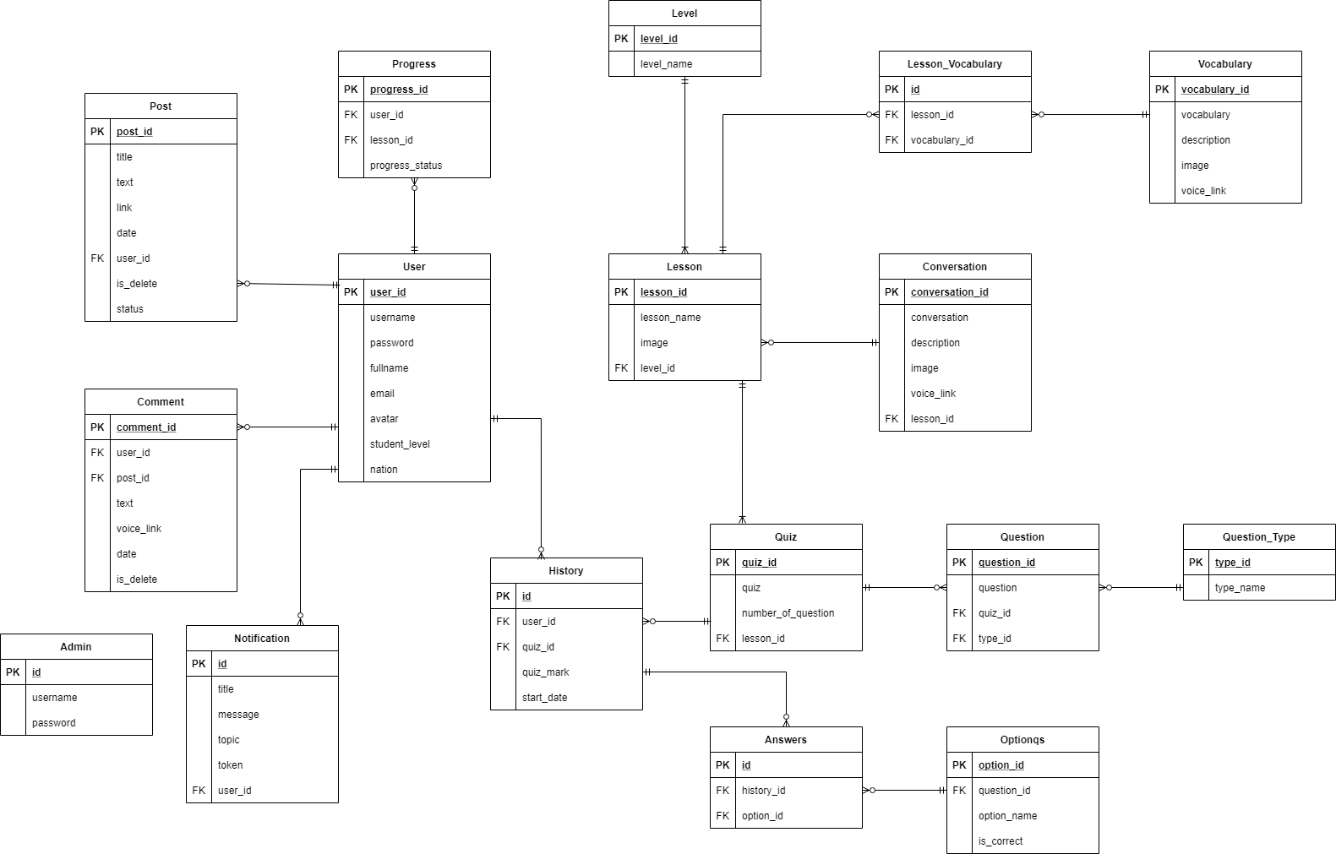

#### 4.1.1. Unauthorized_User

|  |  |  |  |  |  |  |
| --- | --- | --- | --- | --- | --- | --- |
| **Field name** | **Type** | **Size** | **Unique** | **Not Null** | **PK/FK** | **Notes** |
| user_id | int |  | X | X | X |  |
| username | nvarchar | 50 | X | X |  |  |
| password | nvarchar | 500 |  | X |  |  |
| fullname | nvarchar | 50 |  |  |  |  |
| email | nvarchar | 50 |  | X |  |  |
| student_level | nchar | 10 |  |  |  |  |
| nation | nvarchar | MAX |  |  |  |  |
| role_id | int |  |  |  |  |  |
| avatar | nvarchar | MAX |  |  |  | User avatar link |

#### 4.1.2. Level

|  |  |  |  |  |  |  |
| --- | --- | --- | --- | --- | --- | --- |
| **Field name** | **Type** | **Size** | **Unique** | **Not Null** | **PK/FK** | **Notes** |
| level_id | int |  | X | X | X |  |
| level_name | nvarchar | 50 | X | X |  |  |
| status | bit |  |  |  |  |  |

#### 4.1.3. Lesson

|  |  |  |  |  |  |  |
| --- | --- | --- | --- | --- | --- | --- |
| **Field name** | **Type** | **Size** | **Unique** | **Not Null** | **PK/FK** | **Notes** |
| lesson_id | nchar | 5 | X | X | X |  |
| lesson_Name | nvarchar | MAX |  |  |  |  |
| image | nvarchar | MAX |  |  |  | Lesson image link |
| level_id | int |  |  | X | X |  |
| status | bit |  |  |  |  |  |

#### 4.1.4. Vocabulary

|  |  |  |  |  |  |  |
| --- | --- | --- | --- | --- | --- | --- |
| **Field name** | **Type** | **Size** | **Unique** | **Not Null** | **PK/FK** | **Notes** |
| vocabulary_id | int |  | X | X | X |  |
| vocabulary | nvarchar | 50 |  |  |  |  |
| description | nvarchar | MAX |  |  |  |  |
| image | nvarchar | MAX |  |  |  | Vocabulary image link |
| voice_link | nvarchar | MAX |  |  |  | Vocabulary voice link |
| status | bit |  |  |  |  |  |

#### 4.1.5. Conversation

|  |  |  |  |  |  |  |
| --- | --- | --- | --- | --- | --- | --- |
| **Field name** | **Type** | **Size** | **Unique** | **Not Null** | **PK/FK** | **Notes** |
| conversation_id | int |  | X | X | X |  |
| conversation | nvarchar | MAX |  |  |  |  |
| description | nvarchar | MAX |  |  |  |  |
| image | nvarchar | MAX |  |  |  | Conversation image link |
| voice_link | nvarchar | MAX |  |  |  | Conversation voice link |
| lesson_id | nchar | 5 |  |  |  |  |
| status | bit |  |  |  |  |  |

#### 4.1.6. Quiz

|  |  |  |  |  |  |  |
| --- | --- | --- | --- | --- | --- | --- |
| **Field name** | **Type** | **Size** | **Unique** | **Not Null** | **PK/FK** | **Notes** |
| quiz_id | int |  | X | X | X |  |
| quiz | nchar | 10 |  |  |  |  |
| number_of_question | int |  |  |  |  |  |
| lesson_id | nchar | 5 |  |  |  |  |

#### 4.1.7. Question

|  |  |  |  |  |  |  |
| --- | --- | --- | --- | --- | --- | --- |
| **Field name** | **Type** | **Size** | **Unique** | **Not Null** | **PK/FK** | **Notes** |
| question_id | int |  | X | X | X |  |
| question | nvarchar | MAX |  |  |  |  |
| quiz_id | int |  |  |  | X |  |
| type_id | int |  |  |  | X |  |
| status | bit |  |  |  |  |  |

#### 4.1.8. Question_Type

|  |  |  |  |  |  |  |
| --- | --- | --- | --- | --- | --- | --- |
| **Field name** | **Type** | **Size** | **Unique** | **Not Null** | **PK/FK** | **Notes** |
| type_id | int |  | X | X | X |  |
| type_name | nvarchar | 50 |  |  |  |  |
| status | bit |  |  |  |  |  |

#### 4.1.9. Optionqs

|  |  |  |  |  |  |  |
| --- | --- | --- | --- | --- | --- | --- |
| **Field name** | **Type** | **Size** | **Unique** | **Not Null** | **PK/FK** | **Notes** |
| option_id | int |  | X | X | X |  |
| option_name | nvarchar | MAX |  |  |  |  |
| question_id | int |  |  |  | X |  |
| is_correct | bit |  |  |  |  |  |
| status | bit |  |  |  |  |  |

#### 4.1.10. Answer

|  |  |  |  |  |  |  |
| --- | --- | --- | --- | --- | --- | --- |
| **Field name** | **Type** | **Size** | **Unique** | **Not Null** | **PK/FK** | **Notes** |
| id | int |  | X | X | X |  |
| history_id | int |  |  | X | X |  |
| option_id | int |  |  | X | X |  |

#### 4.1.11. Progress

|  |  |  |  |  |  |  |
| --- | --- | --- | --- | --- | --- | --- |
| **Field name** | **Type** | **Size** | **Unique** | **Not Null** | **PK/FK** | **Notes** |
| progress_id | int |  | X | X | X |  |
| user_id | int |  |  | X | X |  |
| lesson_id | nchar | 5 |  | X | X |  |
| progress_status | nchar | 10 |  |  |  |  |

#### 4.1.12. Post

|  |  |  |  |  |  |  |
| --- | --- | --- | --- | --- | --- | --- |
| **Field name** | **Type** | **Size** | **Unique** | **Not Null** | **PK/FK** | **Notes** |
| post_id | int |  | X | X | X |  |
| title | nvarchar | 100 |  |  |  |  |
| text | nvarchar | MAX |  |  |  |  |
| link | nvarchar | MAX |  |  |  |  |
| date | datetime |  |  |  |  |  |
| user_id | int | 10 |  | X | X |  |
| is_delete | bit |  |  |  |  |  |
| status | nchar | 10 |  |  |  |  |

#### 4.1.13. Comment

#### 

|  |  |  |  |  |  |  |
| --- | --- | --- | --- | --- | --- | --- |
| **Field name** | **Type** | **Size** | **Unique** | **Not Null** | **PK/FK** | **Notes** |
| comment_id | int |  | X | X | X |  |
| text | nvarchar | 2000 |  |  |  |  |
| voice_link | nvarchar | MAX |  |  |  |  |
| date | datetime |  |  |  |  |  |
| user_id | int | 10 |  | X | X |  |
| post_id | int |  |  | X | X |  |
| is_delete | bit |  |  |  |  |  |

#### 4.1.14. History

|  |  |  |  |  |  |  |
| --- | --- | --- | --- | --- | --- | --- |
| **Field name** | **Type** | **Size** | **Unique** | **Not Null** | **PK/FK** | **Notes** |
| id | int |  | X | X | X |  |
| user_id | int | MAX |  | X | X |  |
| quiz_id | int |  |  | X | X |  |
| start_date | datetime | 10 |  |  |  |  |
| quiz_mark | float |  |  |  |  |  |

#### 4.1.15. Notification

|  |  |  |  |  |  |  |
| --- | --- | --- | --- | --- | --- | --- |
| **Field name** | **Type** | **Size** | **Unique** | **Not Null** | **PK/FK** | **Notes** |
| id | int |  | X | X | X |  |
| title | nvarchar | 100 |  |  |  |  |
| message | nvarchar | MAX |  |  |  |  |
| topic | nvarchar | MAX |  |  |  |  |
| token | nvarchar | MAX |  |  |  |  |
| user_id | int |  |  | X | X |  |

#### 4.1.16. Lesson_Vocabulary

|  |  |  |  |  |  |  |
| --- | --- | --- | --- | --- | --- | --- |
| **Field name** | **Type** | **Size** | **Unique** | **Not Null** | **PK/FK** | **Notes** |
| id | int |  | X | X | X |  |
| lesson_id | nchar | 5 |  | X | X |  |
| vocabulary_id | int |  |  | X | X |  |

#### 4.1.17. Admin

|  |  |  |  |  |  |  |
| --- | --- | --- | --- | --- | --- | --- |
| **Field name** | **Type** | **Size** | **Unique** | **Not Null** | **PK/FK** | **Notes** |
| id | int |  | X | X | X |  |
| username | varchar | 50 |  | X |  |  |
| password | varchar | 50 |  | X |  |  |

### 4.2 Data File Design

We use Firebase Storage to store files and images

|  |  |  |  |
| --- | --- | --- | --- |
| **#** | **File Name** | **Type** | **Notes** |
|  | Class name1 |  |  |
|  | Class name2 |  |  |